Readings & Assignments: Week 4
Week 4 Readings
Complete the following readings early in the week:
- Week 4 online lectures
- From 3ds Max Help file, read the following topics:
  - Constraint Concepts
  - Link Constraint
  - Assign Controllers
  - Link Strategy
  - Linking and Unlinking Object
While reading, make note of pertinent and important facts. You will be required to reference your readings in discussions and apply them in this week’s assignments.
Week 4 Assignments Overview
Assignment Summary: Week 4 | Due Date
Assignment 1: Discussion Questions | Saturday, March 13, 2010
Assignment 2: The Pencil Animation | Saturday, March 13, 2010
Assignment 3: Animating Balls | Sunday, March 14, 2010
Assignment 4: Final Project | Monday, March 15, 2010
Using the navigation on the left, please proceed to the next page.

Week 4 Overview
In Week 3, you learned about the basic concepts of the animation process, including how to set up and prepare your models for animation. You also learned how to apply keyframes and then adjust those keyframes to give a polished look to an animation. This week, you will expand your knowledge about the concepts of and tools and techniques used in creating three-dimensional (3D) animations.
You will also learn how to create relationships between multiple 3D objects to be able to animate complex models with ease. In this context, you will learn about three animation tools:
- Animation constraints
- Animation controllers
- Linking
Let's begin this week by learning about animation constraints.

Learning Outcomes:
- Exhibit the ability to apply animation techniques to 3D models.
- Show the ability to use advanced controllers in animating and linking models.
- Manipulate animation curves to refine movement and timing.

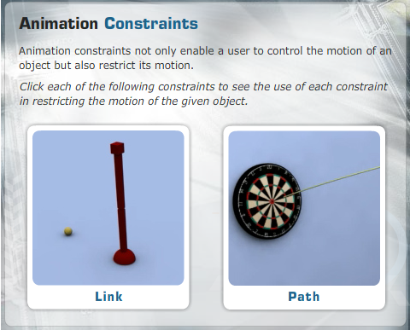
Animation Constraints
You use animation constraints to control an object’s position, rotation, and scale. Animation constraints enable you to automate the animation process by creating a relationship between two or more objects. For example, if you want to animate a fighter plane such that it follows a specific trajectory, creating a path and then constraining the fighter plane to that path will ensure the proper animation of the motion of the plane. The 3ds Max software will automate the animation by applying keys to the timeline once the relationship between the 3D object and the path is created. Some of the most common constraints are the path and link constraints. Animation constraints have different functions; for example, if you require a dart to follow a predefined trajectory, using a Spline tool and assigning a path constraint will ensure a more accurate direction.
With the help of animation constraints, you can manipulate some 3D objects individually or animate as a whole 3D objects that have a hierarchical relationship (objects that have multiple objects linked together to form a relationship). This hierarchical relationship can also be referred to as a parent-child relationship shared by multiple meshes that are linked together.
You can assign multiple constraints to an object. You can select the constraints to make them active and use the cut-and-paste options to transfer them to other objects or delete them completely from an object. The Motion panel can be used to assign a constraint by using the Assign Controller button, the Animation menu, or Track View.
Next, you will learn about animation controllers, another 3ds Max tool that is used to create and simplify 3D animations.

Animation Controllers
Animation controllers work like animation constraints in that they also assist in the animation process by forming a relationship between an object and a target to help make the animation process quicker and more proficient.
One big difference between an animation controller and a constraint is that every object or parameter has a controller automatically assigned to it as soon as it is animated.
3ds Max enables you to assign specific controllers to the position, rotation, or scale transforms of an object. You can assign controllers through multiple tools such as Track View, the Animation menu, and the Motion panel.
When a controller is automatically assigned, you can use Track View or the Motion panel to manipulate the default controller.
When you assign a controller, a rubber-band line extends from the selected object, and by dragging and clicking this line, you can assign a relationship to the target object.
In the next lecture, you will learn about linking, which is an important tool in 3ds Max that assists in creating relationships between multiple objects.

Linking
Linking is one of the most powerful tools that help in the animation process. Linking enables a user to create a hierarchy or chain between multiple objects and affects how those objects are animated. The hierarchy that is created—or the relationship between multiple objects—is known as the parent-child relationship. The order in which multiple objects are linked or parented together determines which object is the parent and which are the children.
The root of the chain is always the parent, and all the children are connected to the parent like a family tree. The object that is the parent in a hierarchical chain can have multiple children, but a child can have only one parent. All children below a parent in a chain are known as Descendants, and the parent above a child is known as Ancestor. Remember that the top of the chain does not have a parent; it is referred to as root and controls the rest of the chain.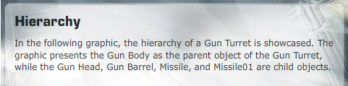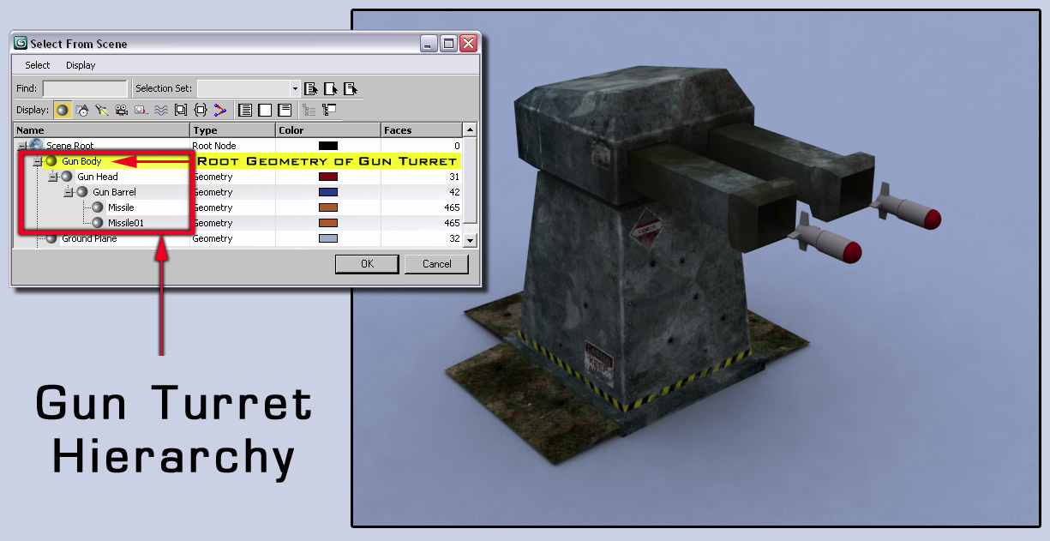

The primary benefit of creating a parent-child relationship is to be able to move or animate complex chains together in a 3D environment; this is known as kinematics. You will use a method known as Forward Kinematics (FK) to transform (move, scale, or rotate) the parent object to affect the movement of the child. FK refers to how movement is transferred through the hierarchy from the parent to the child.
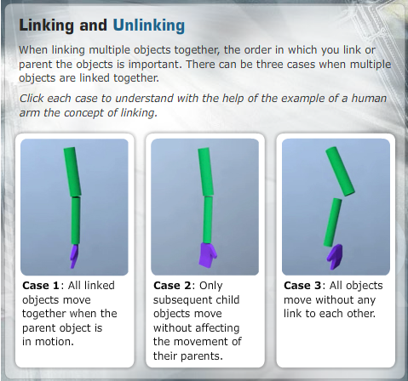
It is important to know that it is always the child object that is linked to the parent object. So if you were to link a human arm, you should start with the wrist (the child object) and link it through the elbow to the shoulder (the parent object). This would make the shoulder the root, as well as the parent of the elbow and the wrist.
3ds Max provides you the option to break the hierarchy or destroy the entire hierarchical chain between multiple objects. To completely get rid of any relationship between multiple objects, make sure to first select the entire hierarchy and then use the Unlink button. If you select a child in the chain and unlink, you will break its link to the parent of the selected object. This brings us to the end of this week's lecture. Let's summarize the key learning from the week.

Summary
This week, you built on the fundamentals of animation and were introduced to new tools and techniques that assist in making the animation process easier. You learned that assigning animation controllers and constraints to objects enables you to automate as well as restrict specific motions of these objects.
You also discussed about the importance of linking to create a parent-child relationship, or a hierarchical chain, among multiple objects. You learned that linking enables you to use kinematics, specifically FK, to animate multiple objects and transfer that motion from the parent to the children.
Next week, you will review some of the key concepts explored over the last weeks.

Assignment 1: Discussion Questions
By Saturday, March 13, 2010, respond to the discussion questions assigned to you by the facilitator. Submit your responses to the appropriate Discussion Area. Start reviewing and responding to your peers’ posts as early in the week as possible. You can ask a question, post a comment, or add a point to expand the discussion. Be honest, clear, and concise.
Always use constructive language, even in criticism, to work toward the goal of positive progress. Make sure to use your course text or other research when possible in your responses.
Support your statements with appropriate references wherever necessary. Follow current MLA guidelines for writing style, spelling, grammar, and citation of sources.
Assignment 1 Grading Criteria | Maximum Points
Response Criteria:
Met the criteria for the correct responses to the questions assigned. | 4
Used vocabulary relevant to the current and previous weeks' topics—at least five terms. | 4
Participation Criteria:
Used vocabulary relevant to the current and previous weeks' topics—at least five terms. | 4
Participated in the discussion by asking a question, providing a statement of clarification, providing a point of view with a rationale, challenging a point of discussion, or making a relationship between two or more points of the discussion. | 4
Justified ideas and responses by using appropriate examples and references from textbooks, Web sites, and other references or personal experience. | 4
Total: | 20
For assistance with any problems you may have when completing this assignment—OR—to offer your assistance to classmates, please use the Problems and Solutions Discussion area located through the left side navigation link.
This week it's all about animation. As we prepare to set up our vehicles for animation we must understand how to deal with the rigging process. While you will hear the word "rigging" usually associated with the use of joints and bones, we refer to rigging whenever there is a setup that requires a specific hierarchy to produce the desired result.
This week answer questions 1 and 3. Post your answers here and reply to the work posted by at least 2 of your peers.
DQ 1: What does a parent-child relationship mean in a 3D animation? How does it affect computer-generated animation? What are some of the important factors in making sure hierarchy has been created properly? Justify your answer with appropriate examples and rationale.
DQ2: What is the primary benefit of a parent-child relationship? Give an example of how linking objects together could help in the animation process.
DQ3: You are animating a computer-generated object and want to ensure more accurate timing, weight, and other physical properties of the motion. What can you adjust on keyframes to achieve the desired result?
DQ4: How can the Dummy object assist with animation? State at least two benefits of using the Dummy object.

Assignment 2: The Pencil Animation
In this assignment, you’ll animate a pencil along a path to give the impression that it is writing your name in cursive writing.

Perform the following:
- Create a pencil using basic modeling techniques and apply colors to the different sections of the pencil to enhance the look of the mesh. In addition, create a floor plane that will give the impression of a paper.
- Create a path for the pencil to follow. The path should resemble your first name when written in cursive. Refine the path so there is a natural flow to the spline.
- Using constraints and function curve, make adjustments to the animation to give the impression that the pencil is writing your name.
- In the perspective view, render out the entire animation as a 320 x 240 pixel QuickTime movie. Ensure that spline is visible in the final render.
- Save the file as W4_A2_LastName_FirstName.mov and submit it to this Discussion Area by Saturday, March 13, 2010.

Discussion
By the end of the week, use this Discussion Area to discuss the following:
- How did using a path help or cause problems in making the pencil look like it was writing your name?
- What were some of the adjustments made to enhance the look of pencil writing?

Critique Exercise
By the end of the week, use this Discussion Area to review and comment on the assignments posted by at least two of your peers. Comment on the following:
- Did the pencil animation have a natural feel of someone writing a name?
- How was the timing and the flow of the spline path?
- What are some options to improve on the animation, if any?
Assignment 2 Grading Criteria | Maximum Points
Created a pencil mesh with colors to enhance its look and make it appear like a real pencil. | 10
Developed a path animation giving the impression that the pencil is writing your name. | 20
Discussed the role of path in the animation and stated the adjustments made to enhance the look of pencil writing. | 5
Participated in discussion and critique exercise based on the guidelines. | 10
Total: | 45
For assistance with any problems you may have when completing this assignment—OR—to offer your assistance to classmates, please use the Problems and Solutions Discussion area located through the left side navigation link.
Read First:
This is a fantastic project that will give you a better understanding about the animation capabilities of the program at hand. Not everything needs to be keyframed from scratch and there is plenty that can be obtained "procedurally" within the package. This allows for more complex motion to be attained more automatically and with less demands on the artist, specially at crunch time on a project.
A question that always comes up with this assignment is "how can we get the line to show up under the pencil?". There is no one button solution for that (nor just one solution for it), so I will be posting a tutorial on how to do this as part of the thread. You can also search online for other alternatives to accomplishing this same result.
Post your results here and provide feedback to at least two of your peers.

Assignment 3: Animating Balls
In this assignment, you will further your learning on animation principles and create another bouncing ball animation. However, this time you will exhibit the role weight, size, and motion play in an animation by creating an animation for a bowling ball and a ping-pong ball.

Perform the following:
- Use a standard sphere and animate it to resemble the physical properties of a bowling ball and a ping-pong ball.
- Think about techniques other than animation that can help you achieve the desired aesthetics for the two balls and apply them in your animation.
- Add a floor plane and lighting with shadows to enhance the look of the animation.
- Render the animation as a 320 x 240 pixel QuickTime movie and save the file as W4_A3_LastName_FirstName.mov. Submit the file to this Discussion Area by Sunday, March 14, 2010.

Discussion
By the end of the week, use this Discussion Area to discuss the following:
- How did you approach the ball bounce this time when compared to the rubber ball bounce from the previous week's assignment?
- How did the rubber ball bounce animation from the previous week's assignment help the setup and keying of this animation?

Critique Exercise
By the end of the week, use this Discussion Area to review and comment on the ball bounce animation posted by at least two of your peers. You should focus on how naturally the ball bounces and how well the ball bounce imitates the real bounce.
Assignment 3 Grading Criteria | Maximum Points
Created a ball bounce animation as stated in the instructions and submitted a 320 x 240 pixel QuickTime movie of the same. | 20
Added textures and enhanced the material to provide the spheres the look of a bowling and a ping-pong ball. | 10
Used lighting and shadows effectively to show the contact of the balls to the floor plane. | 10
Discussed the difference in approach this time as compared to the previous week's assignment and explained if the rubber ball bounce animation from the previous week's assignment helped the setup and keying of this animation. | 10
Reviewed and critiqued the submissions of at least two peers on the basis of the critiquing guidelines. | 10
Total: | 60
For assistance with any problems you may have when completing this assignment—OR—to offer your assistance to classmates, please use the Problems and Solutions Discussion area located through the left side navigation link.

Read First
Another great assignment that will give you more practice with the animation tools. Across the board everyone did a terrific job with the bouncing ball assignment last week. This week, we will work on a similar idea but showing two different materials. So imagine that we have a ping pong ball and a bowling ball. How will each one react? Which one will bounce more? Which one will feature a more evident squash on each bounce? Will the bowling ball bounce at all? These are just some of the questions that you must answer in order to attain a good animation for this project.
Very important: we want both balls in the same shot. We are not looking for two separate animations but rather a single scene with both balls side by side. Also, think that, unlike last week, this is not a rubber ball but a ping pong ball. It will be smaller than the bowling ball and bounce differently than last week's one.
Once you are done, post your result here and comment on the work of two of your peers.

Assignment 4: Final Project
This week, you’ll start to animate your vehicle. Think about moving parts and how they will affect the environment. Begin to animate the areas of the environment also. Do a few motion tests of the animation. IT IS MANDATORY THAT YOU POST FREQUENTLY!
Perform the following:
- Start to do animation sets of the vehicle in motion. Be creative in the motions you choose. Try to use motions that will really push the futuristic elements of the vehicle.
- Begin to animate some elements of the environment. Try to make this as realistic as possible. Find ways to connect the vehicle animation to the environment animation
- Posted at least 3 versions of both the vehicle and environment animations. These are your in progress files. You will receive feedback upon each post so you can continue to make any needed changes
Save the files as W4_A4_VehAnim_LastName_FirstName.max and W4_A4_Env Anim_LastName_FirstName.max submit them to this by Tuesday, March 16, 2010.
Discussion
By the end of the week, use this Discussion Area to discuss the good and bad elements of the animation tests that you see in your own work (self critique).
Critique Exercise
By the end of the week, use this Discussion Area to review and comment on the assignments posted by at least two of your peers. Provide constructive feedback on the vehicle and environment animations.

Assignment 4 Grading Criteria | Maximum Points
Submitted the 3ds Max file with some strong vehicle animation | 30
Submitted the 3ds Max file with some strong environment elements animation | 30
Posted at least 3 versions of both the vehicle and environment animations | 20
Discussed the good and bad elements of the animation tests of your own work (self critique) | 10
Reviewed and critiqued the submissions of at least two peers on the basis of the critiquing and discussion guidelines. | 10
Total: | 100
For assistance with any problems you may have when completing this assignment—OR—to offer your assistance to classmates, please use the Problems and Solutions Discussion area located through the left side navigation link.

Read First
Continuing with our final, this week we want to start working on the animation of the scene. Think about everything you want to move around and how it will do it. Block out the action by using just a few keyframes rather than jumping straight ahead into the finer details. A normal production pipeline would approach an animated scene in the following manner:
- Blocking pass: using very few keyframes (and usually STEP TANGENTS) we establish the timing of the scene and the key poses/positions our character needs to hit. No in- betweens (hence the STEP TANGENTS)\
- First animation pass: now we go back over the blocking and start adding in- betweens to major body parts only. For example, we don't care about fingers or clothing. We care about major limbs such as arms and legs.
- Second animation pass: Here we go back and animate the extra details such as fingers, hair, clothing, props, etc.
- Refinement: With all the animated elements in place we go over the animation once again tweaking and adjusting them so they work cohesively.
- Clean- up: finally we get rid of unnecessary keys, reference objects, and anything else not pertinent to the final animation. This step is critical since, in a production pipeline, this scene will end up in someone else's hands, and leaving things that person won't need to perform his duty will only add clutter to an already complex scene.
This "iterative" approach gives you more control over a scene and makes it less overwhelming than animating details straight ahead.
Post your work here and provide feedback to at least two of your peers.

